October 2024

Welcome back!

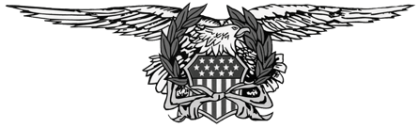

**ABATE OF WASHINGTON**

The Motorcycle Swap Meet, hosted by ABATE of Washington, is scheduled for **Sunday, March 23th, 2025 at the**

**Evergreen State Fairgrounds in Monroe**. We are optimistic that shoppers will be eager to turn out. Many of our vendors have indicated they will participate, and we hope you can too. We’ve reserved the Event Center and Pavilion, providing over 46,000 s.f. of indoor shopping space.

**Updates for 2025**

**BIKE CORRAL**

**WALL SPACES**

**OVERNIGHT & RV PARKING**

**MEMBER DISCOUNT**

**PAYMENT BY CREDIT OR DEBIT CARD**

**PAYMENT BY CHECK OR MONEY ORDER**

Returning this year is an indoor parking area in the Pavilion for selling complete running bikes. It’s a good option for those who don’t need a full 10’x10’ space. The cost is $20 per motorcycle which includes 1 wristband. No parts sales, merchandise, or service sales inside the corral.

If you’re applying for space along one of the interior walls in either building after February 15, email [swapmeet.abateofwashington@gmail.com](mailto:swapmeet.abateofwashington@gmail.com) check availability. Wall spaces usually sell out early. If you’ve paid for wall space and it’s not available, a prorated refund will be applied.

Overnight camping (RV, trailer, camper, tent, vehicle) is available in fairgrounds lot **RV-2 only**. No overnight camping in the inside lots near the event buildings. **WATER MAY NOT BE AVAILABLE**

Receive a discount on space rental by joining ABATE of Washington. A membership coupon is at the bottom of this page for those wishing to sign up and save.

Pay for your space by credit card, debit card, or SQUARE. Email the signed registration form to [swapmeet.abateofwashington@gmail.com.](mailto:swapmeet.abateofwashington@gmail.com) We will then email an invoice to you for secure online payment.

If credit/debit card or SQUARE payment is not an option, mail the signed registration form along with check or money order to:

ABATE of Washington Swap Meet PO Box 8369 Tacoma, WA 98419

Vendor space reservations are **first come, first served**, so apply early. Please complete all information legibly. Read and keep the enclosed vendor agreement for your records. Contact (253) 353-2235 or email [swapmeet.abateofwashington@gmail.com](mailto:swapmeet.abateofwashington@gmail.com) if you have any questions. Thank you for your interest and participation to help make this a successful event!

Swap Meet Committe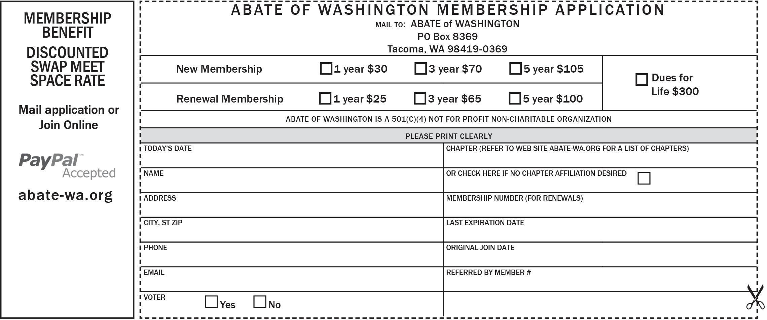e